Before you start the Capstone, you must perform some initial setup to create your S3 bucket and copy the ADS-B data into that bucket. This document walks you through that setup.

Pre-Requisites

Before following these instructions, create your demo account in the AWS region closest to you following [these instructions](https://docs.google.com/document/d/1dlO3_2oE6te308647cNMx8ZFzSxS72fNEoTEq_xMrL0/edit?usp=sharing) (same instructions in your SE Checklist). It’s best that your demo account and S3 bucket are created in the same AWS region to limit any performance issues with latency. Refer to [Supported Cloud Regions](https://docs.snowflake.com/en/user-guide/intro-regions) in the documentation for the list of cloud regions and IDs.

High level steps for doing the Initial Capstone Setup

1. Get Access to the “SE Capstone Sandbox” AWS environment
2. Create an S3 bucket in the same region as your Demo account
3. Copy ADS-B data into the bucket

## 

# Get Access to “SE Capstone Sandbox” AWS environment

| For the Capstone, you MUST use the AWS Environment named “SE Capstone Sandbox”. There’s another AWS environment called “SE Sandbox” so DON’T get confused and choose that one. Choose the “SE Capstone Sandbox” environment.  **\*\*IMPORTANT** The “SE Capstone Sandbox” environment IS NOT A PLAYGROUND OR DEMO ENVIRONMENT! If we see artifacts other than those required for the Capstone, they will be removed.**  There is another environment called “SE Sandbox” that you should be using to create AWS artifacts to support demos and such. |
| --- |

Please follow the instructions below to get access to the “SE Capstone Sandbox” AWS environment.

1. Submit an [AWS Sandbox Request Lift Ticket](https://lift.snowflake.com/lift/?id=sc_cat_item&sys_id=de9fc362db7dd4102f1c9eb6db9619ed) or go to Lift and search for “AWS Sandbox Request”.
2. Fill in the form as follows: **Remember to choose “SE Capstone Sandbox” for the sandbox environment.**



1. If you don’t get access within 4-6 hours after submitting the form, send a slack to #sales-boot-camp-support (mention @william.summerhill and @rob.horbelt).
2. After you receive access, you should see the following AWS Single Sign-On tile in your Snowbiz.okta. Click on it and sign in.

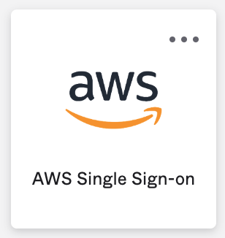

1. You will be redirected to a page like below. Expand the **SE-Capstone-Sandbox** link and select the **“Contributor”** link.



1. A new tab will open placing you in the AWS Sandbox Management Console.

## 

## 

# Create your S3 Bucket

1. From Console Home, select the region where your demo account is located from the picklist. This is important because this is where you will be creating your bucket and you want your bucket and demo account in the same region for performance.



1. In the Search box, type “S3” and select the S3 service.



1. Make sure you are in the same region where your Demo account is created before proceeding (see Step 1). Select “Create bucket”.



1. Name your bucket using the convention **“capstone-<ldap_name>”**. Please follow the naming convention of “capstone-<ldapusername>” where <ldapusername> is typically the first letter of your first name followed by your lastname (i.e. John Snow = jsnow).



1. Enable Bucket Versioning

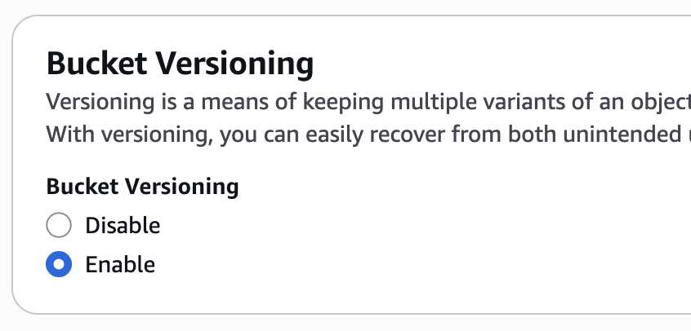

1. Click “Create bucket”.



## 

## 

# Copy Capstone data into bucket

This step involves creating an AWS batch copy job to copy all the ADS-B data from the source bucket (dkaviation-source) into your new bucket you just created.

1. Go to the S3 Services console



1. In the left-hand navigation pane, select “Batch Operations”



1. Click “Create job”



1. For "Manifest," choose S3 inventory report



1. Copy and paste the s3 url below into the Manifest Object text field. Click Next.
   * s3://capstone-logs3/dkaviation-source/dkaviation-source-inventory/2025-06-29T01-00Z/manifest.json



1. For “Operation”, choose “Copy”.



1. For "Destination," browse for and select the bucket that you created for yourself. Scroll down and click “Next”.



1. For “Description” in Additional Options, put something like “<date> - copy to <your bucket name>” so that you can find the job to start it (see screenshot below)



1. In "Completion report destination" textbox, copy and paste the following text

**s3://capstone-logs3**



1. For Permissions, select “Choose from existing IAM roles. Search for “capstone-s3-replication-role” and select it.



1. Click “Next”.
2. Click “Create job”.
3. You will be redirected to the “Batch Operations” screen. Search for your job by entering your bucket name in the search field. Click the “Job ID” link.



1. Select “Run job”.



1. On the next screen, scroll to the bottom and click “Run Job” button.



1. The next screen shows the status of the copy job. Periodically click the refresh button and check the “% Complete” in the “Status” section. That should update with each click of the refresh button. It should take about 20 minutes (at most 30 minutes) for all the data to be copied to your bucket.



1. **Inspecting your Bucket**: After copy is 100% complete, browse your S3 bucket folders to make sure the data is there. For kapa-0001, max date should be May 31, 2025. For kbfi-0001, max date should be Nov. 14, 2021.

# 

# Next Steps

Congratulations! You are ready to begin working on your Capstone.

Setup your Storage Integration and External Stage

To get access to your bucket within Snowflake you’ll have to setup a storage integration and external stage. Read [Configuring Secure Access to Amazon S3](https://docs.snowflake.com/en/user-guide/data-load-s3-config.html)in the documentation to understand how External Stages work in Snowflake. **Please follow instructions for Option 1.**

**WARNING: DO NOT delete any of the files from your S3 bucket! If you do, you will have to recreate your bucket! DO NOT use the PURGE option when running the COPY command as that will delete files from your bucket! DO NOT issue a “rm @stage” command as that will remove files from your bucket!**

Setup the File Stream (when you’re ready)

Part of the POC requirements involves creating a pipeline that incorporates a stream of files that are copied into your bucket (aka trickle-feed). You will need to setup and run code in your demo account to run the file stream. When you’re ready, import the following SQL files into worksheets in your demo account to setup and manage the file stream.

* [setup_capstone_file_stream.sql](https://drive.google.com/file/d/12azKp6QpOxUbYfG_8O4Nf6OXNtLAQVus/view?usp=drive_link): Use this worksheet to setup the file stream.
* [manage_capstone_file_stream.sql](https://drive.google.com/file/d/1Sg4lsADX6JE0if4vidc4pwN2OeT1BSgR/view?usp=drive_link): Use this worksheet to manage the file stream.